1. Design TM using simulator to accept the input string anb2n

INPUT:

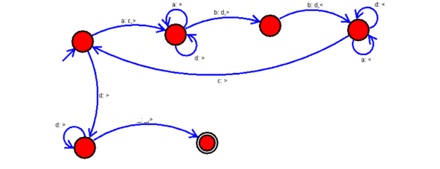

OUTPUT:

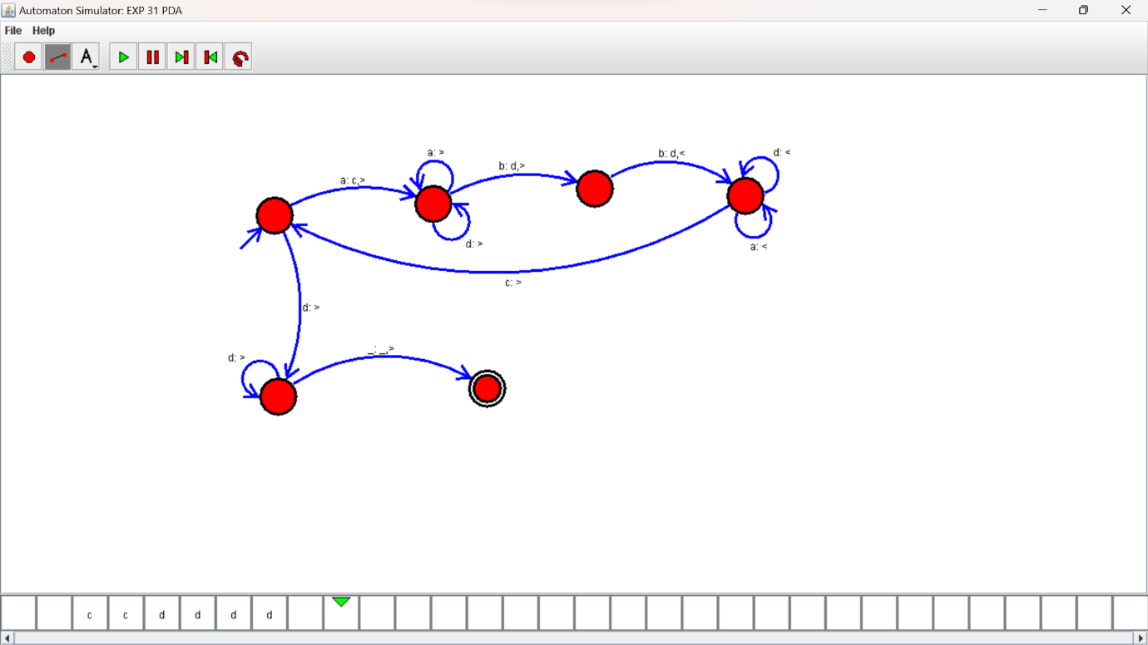

RESULTS:

TM using simulator to accepting the input string anb2n